Phase 5 – Deployment, Documentation and Final Presentation
Document Setup Manual

Phase Overview
This document provides a complete setup guide for recreating the metro ticket booking solution in a new ServiceNow Personal Developer Instance (PDI). It outlines the sequence of configurations required across Service Catalog, Flow Designer, scripts, notifications, and security controls.

1) Purpose
The purpose of this setup manual is to enable administrators or developers to independently recreate, configure, and test the metro ticket booking system in a fresh ServiceNow environment. The document ensures consistency, accuracy, and ease of deployment.

2) Prerequisites
Before beginning the setup, ensure the following:
- Access to an active ServiceNow PDI
- Admin role enabled
- Service Catalog and Flow Designer plugins available

3) Catalog Item Creation
A) Create Service Catalog Item
Navigate to Service Catalog → Maintain Items and create a new catalog item named Book A Metro Ticket. Assign it to the Service Catalog and appropriate category to ensure visibility in the Service Portal.
B) Configure Catalog Item Properties
Provide a short description and configure catalog item settings as required. Save the item to proceed with variable configuration.

4) Variable Configuration
A) Create Form Variables
Add variables under the catalog item to capture journey, passenger, and payment details. Use appropriate variable types such as String, Choice, Reference, Integer, and Date.

B) Variable Settings
Configure variable order, mandatory settings, tooltips, and default values. Apply UI policies where conditional visibility is required.
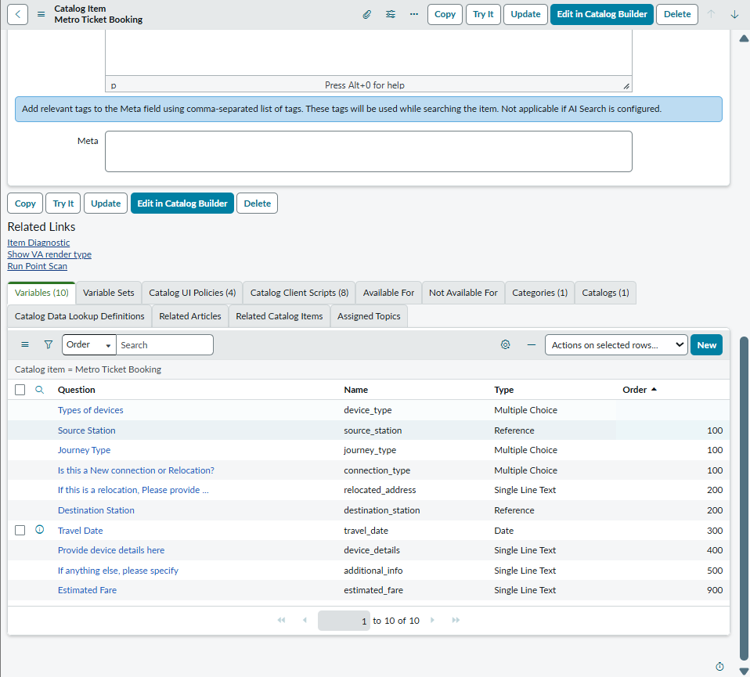

5) Flow Designer Workflow Setup
A) Create Flow
Navigate to Flow Designer, create a new flow, and configure the trigger as Service Catalog → Requested Item.

B) Configure Flow Actions
Add actions to:
- Retrieve catalog variables using Get Catalog Variables
- Create records in the Metro_Database table
- Handle conditional logic where required
(Screenshot to add: Flow Designer canvas view)

6) Script Configuration
A) Catalog Client Scripts
Configure catalog client scripts for:
- Fare auto-population
- QR code generation on submission
- Field-level validations
Keep scripts minimal and focused to ensure maintainability.
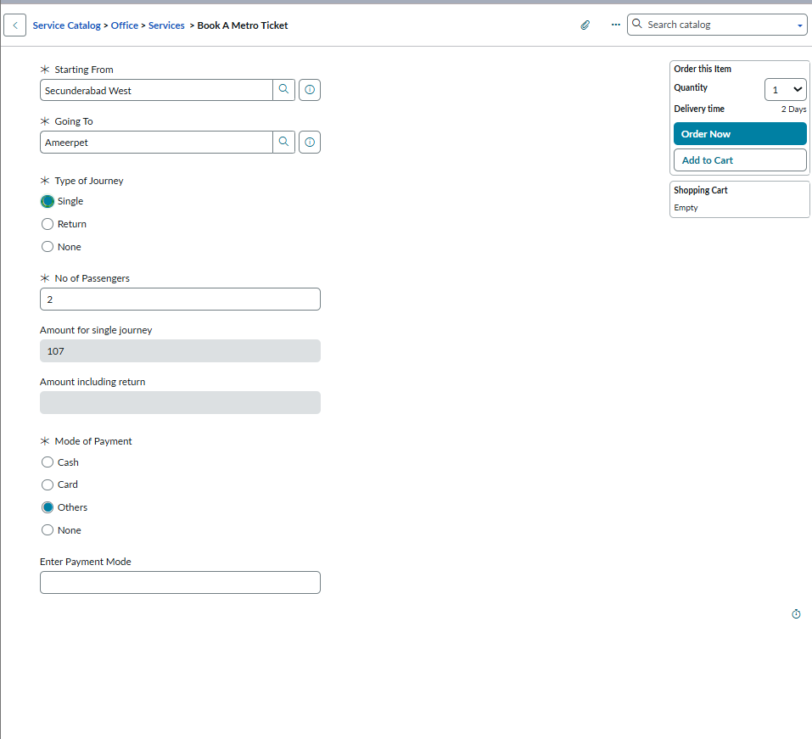
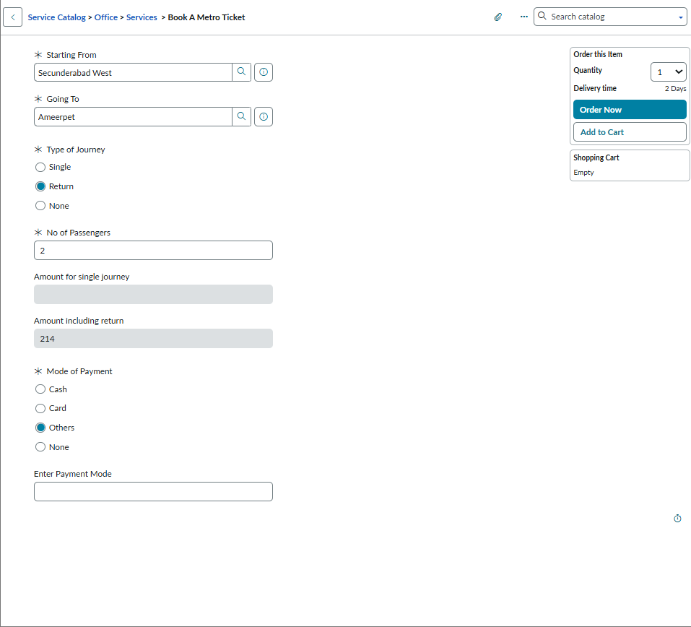

7) Notifications Setup
A) Notification Configuration (If Applicable)
Configure notifications to inform users about ticket booking confirmation or request status. Link notifications to appropriate events or flow actions.
(Screenshot to add: Notification configuration page)
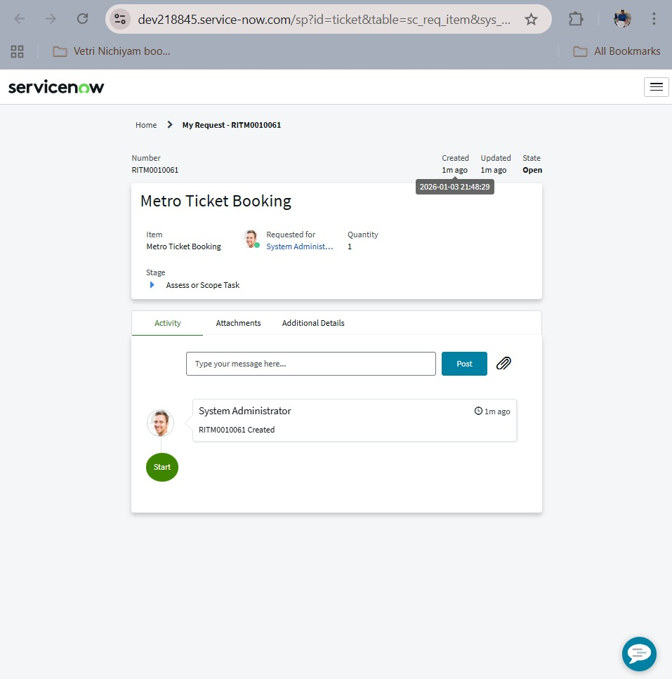

8) ACL and Role Configuration
A) Access Control Setup
Verify default ACLs created for the Metro_Database table. Ensure users can book tickets through the catalog but cannot directly access backend tables.

B) Role Validation
Assign appropriate roles to admins and users to maintain security and data integrity.
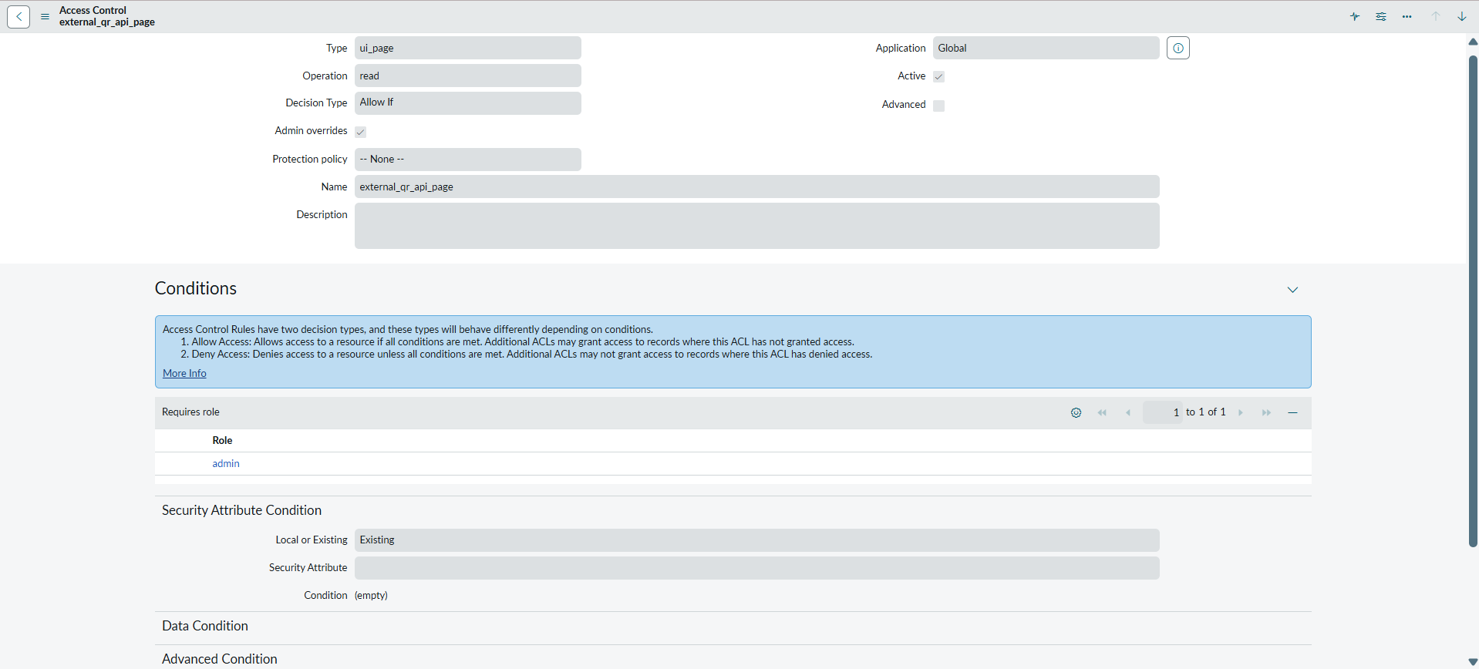

9) Test Submission and Validation
A) Test Booking Submission
Submit a test request through the Service Portal using the Book A Metro Ticket catalog item. Verify fare calculation, QR generation, and request creation.

B) Data Verification
Confirm that submitted values are correctly stored in the Metro_Database table and that flows execute successfully.

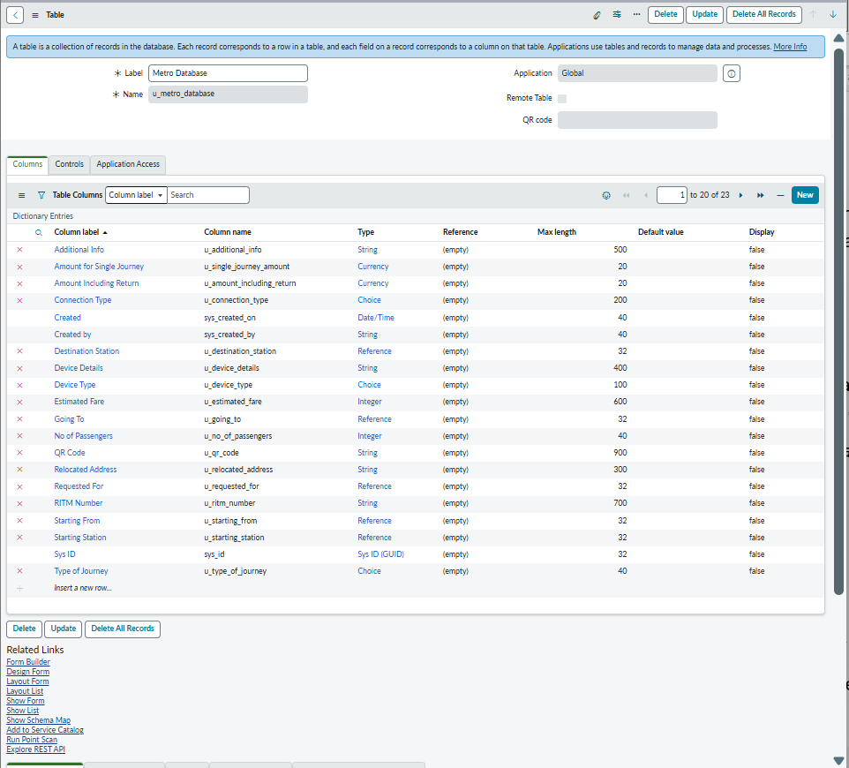

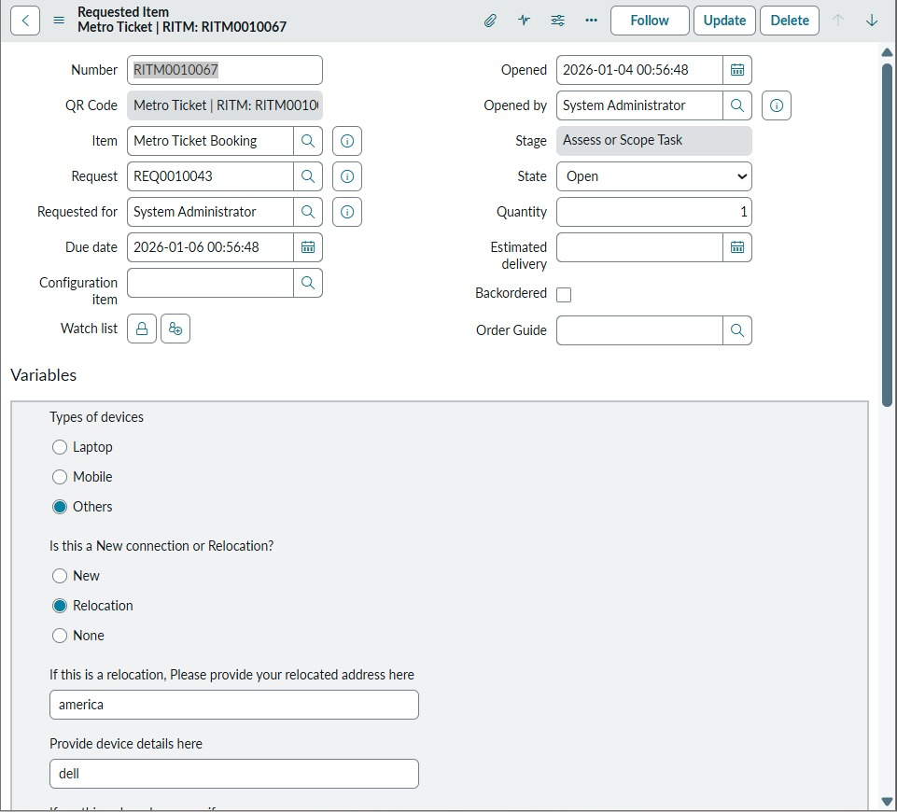

10) Order of Operations Summary
- Create Catalog Item
- Configure Variables
- Set Up Flow Designer Workflow
- Add Client Scripts and UI Policies
- Configure Notifications
- Validate ACLs and Roles
- Perform Test Submissions

11) Outcome
Following this setup manual allows complete recreation of the metro ticket booking system in a new PDI with consistent behaviour, security, and automation. The documented steps ensure smooth handover and future scalability.

